ASTE 404
HW7 Write Up
Nikita Persikov

Problem 2 (Unit Testing):

I used the method from this website: https://www.eriksmistad.no/getting-started-with-google-test-on-ubuntu/

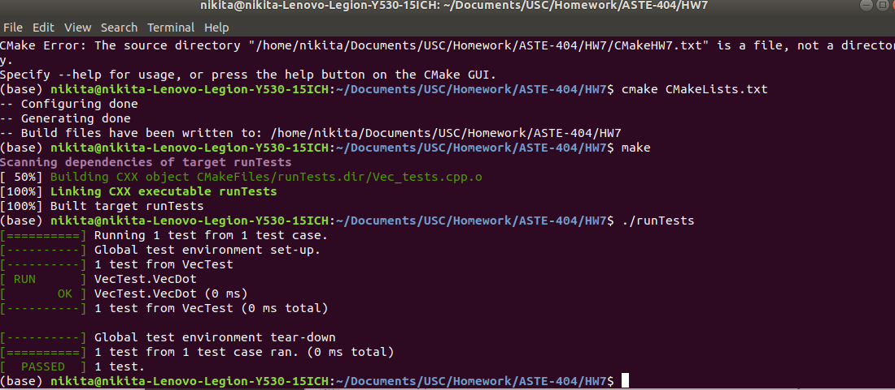
and got this passing result for the simple dot() unit test.

For the advanced version with the class (PART C), I got this result with the same method of compiling the cmake text file:

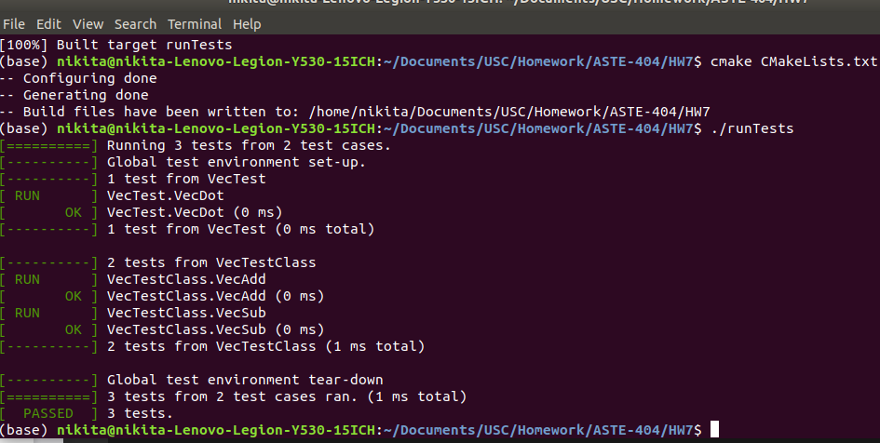
Problem 3:

